Macintosh HD:Users:NeoHanWei:Desktop:Screen Shot 2012-02-16 at 6.57.22 PM.pngMacintosh HD:Users:NeoHanWei:Desktop:Screen Shot 2012-02-15 at 2.50.52 AM.png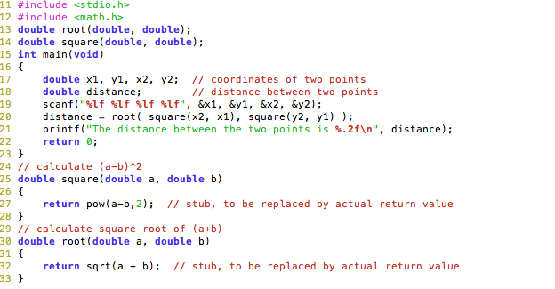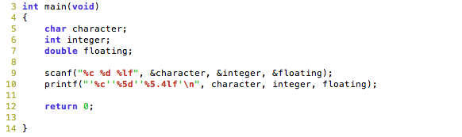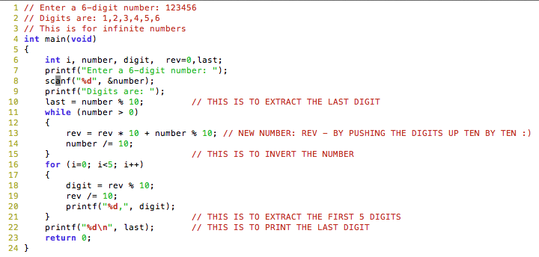Macintosh HD:Users:NeoHanWei:Desktop:Screen Shot 2012-02-16 at 7.13.41 PM.png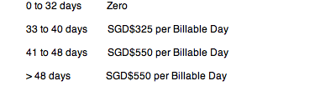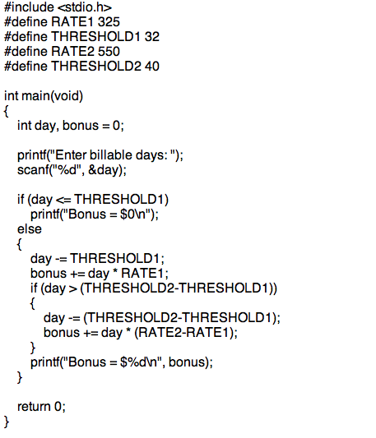Macintosh HD:Users:NeoHanWei:Desktop:Screen Shot 2012-02-15 at 2.55.30 AM.png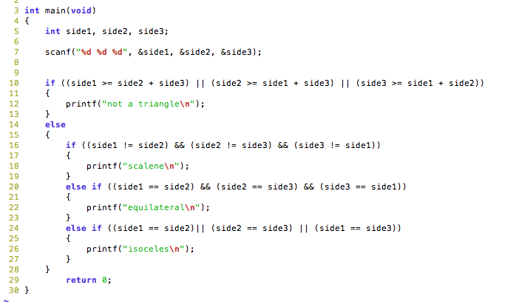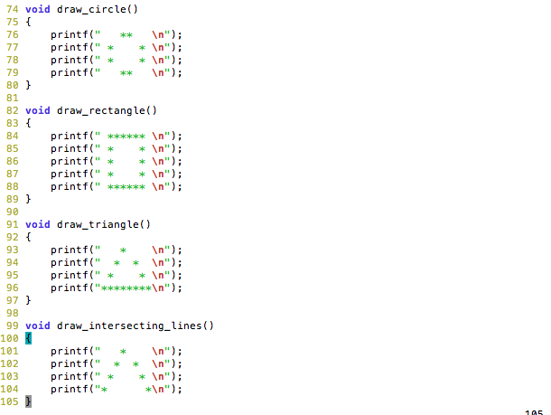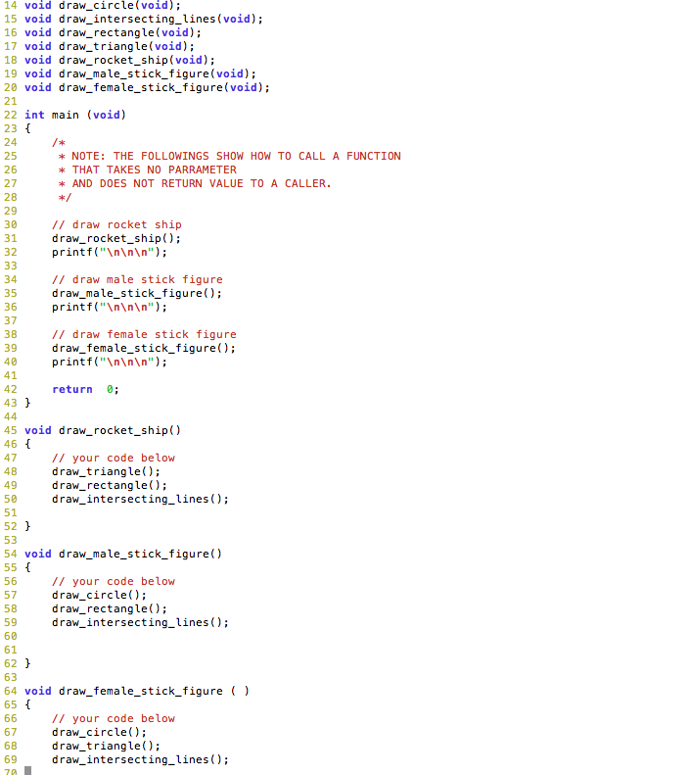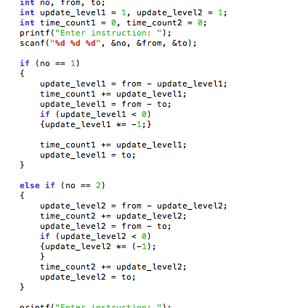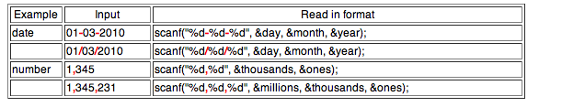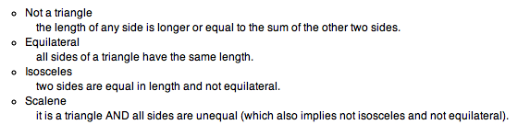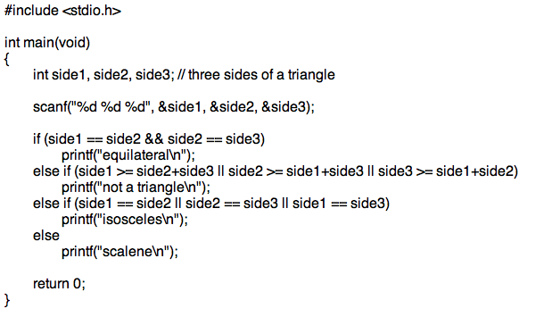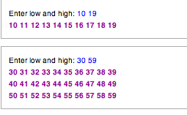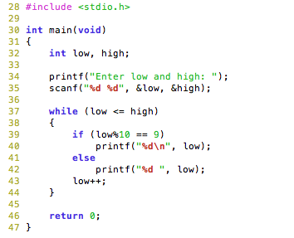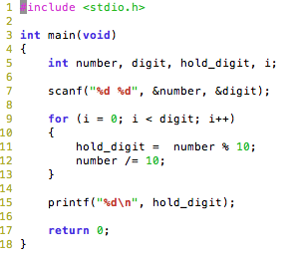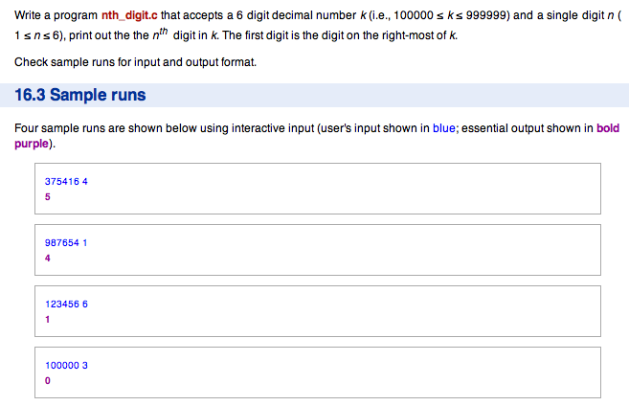Macintosh HD:Users:NeoHanWei:Desktop:Screen Shot 2012-02-16 at 7.39.57 PM.png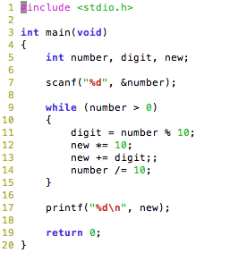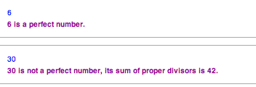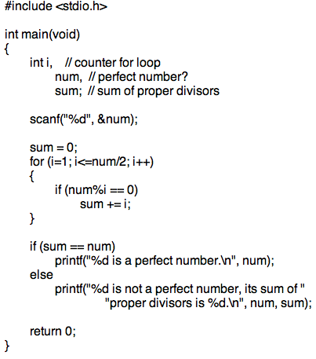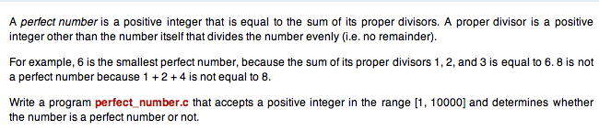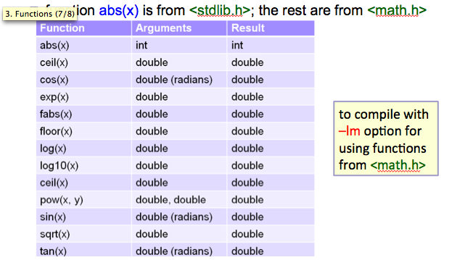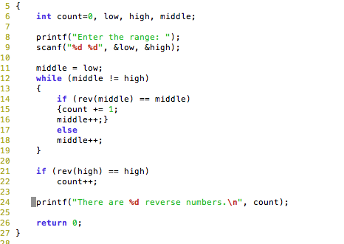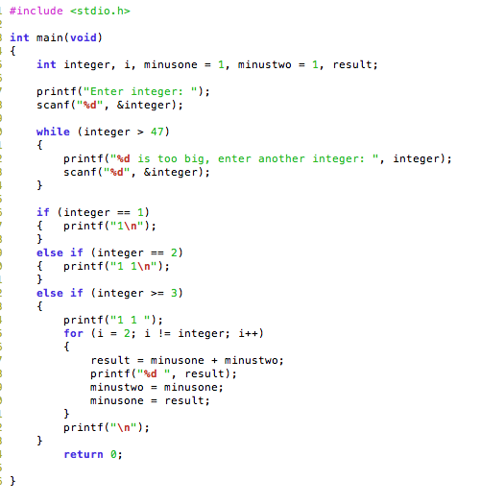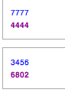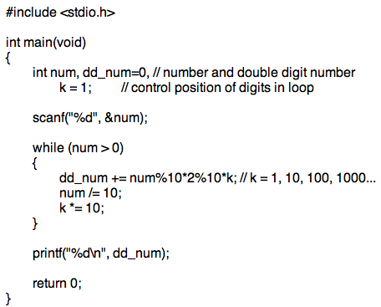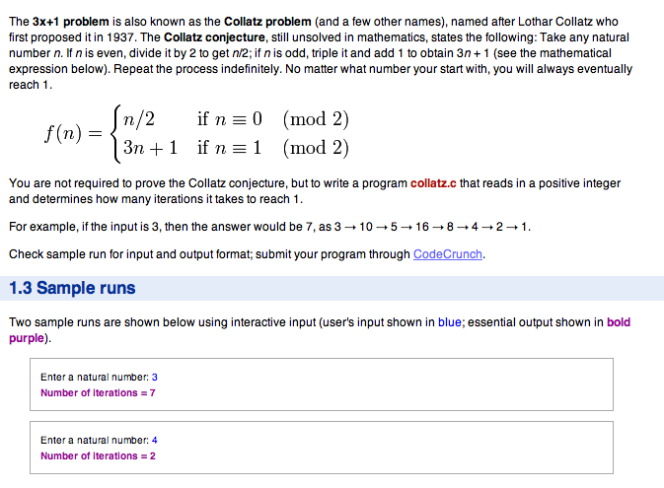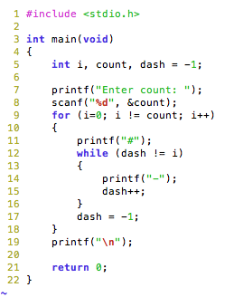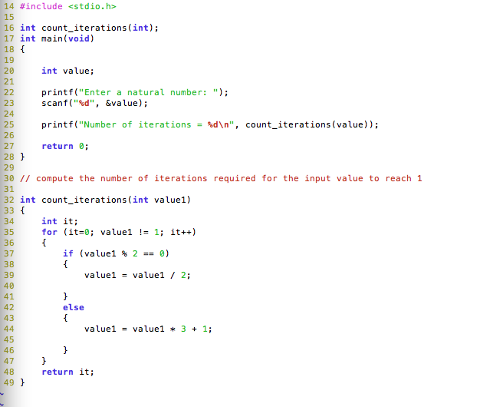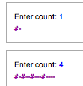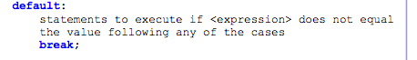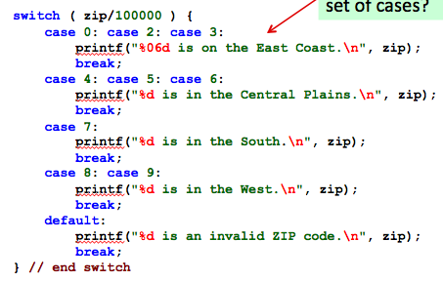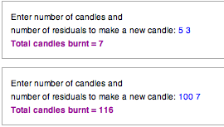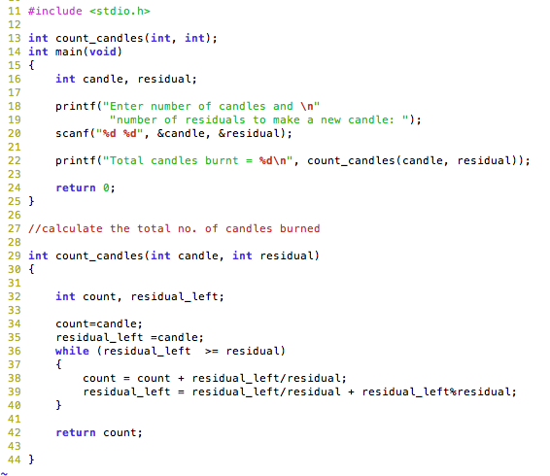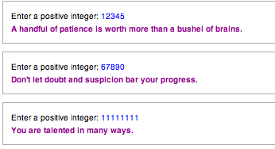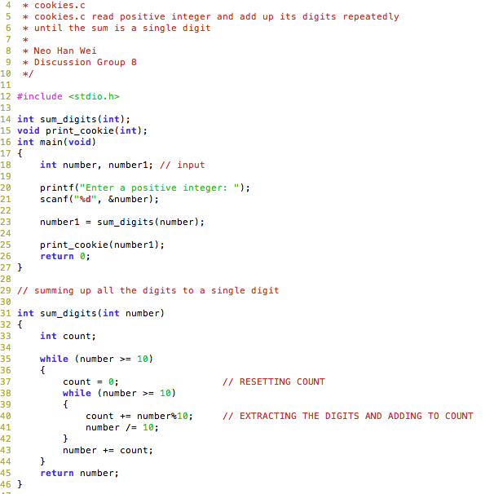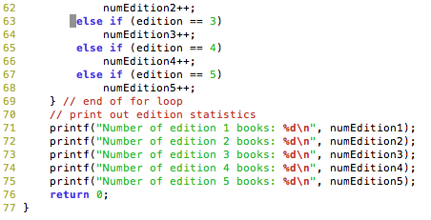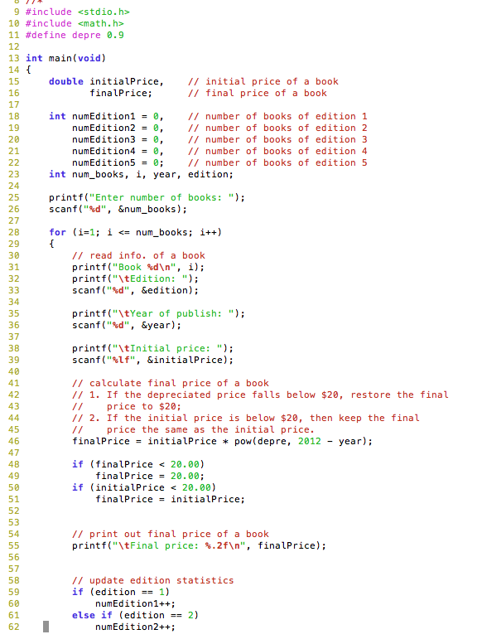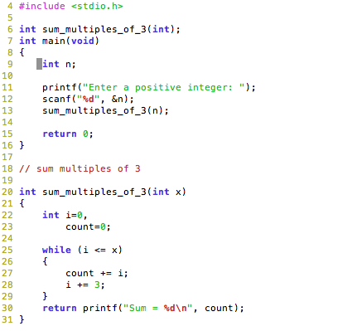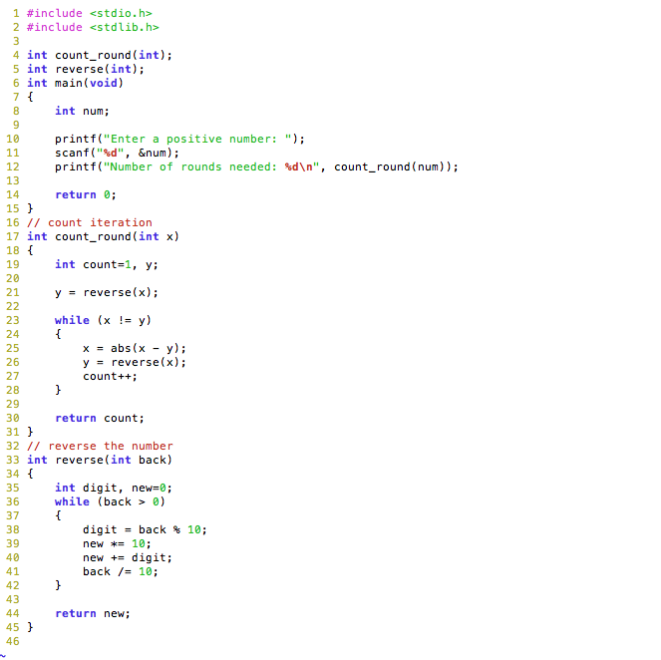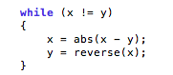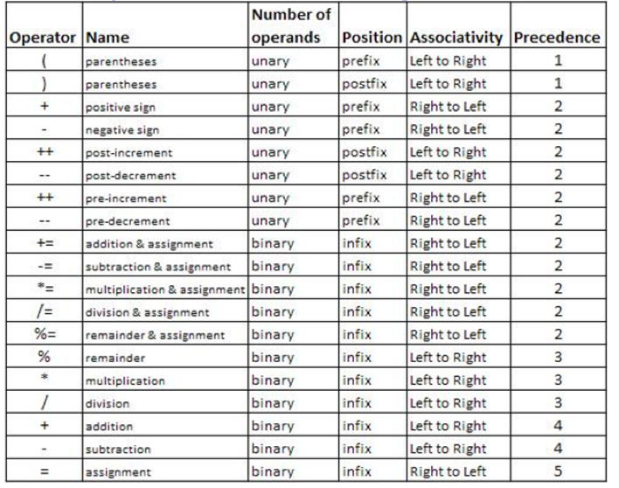Macintosh HD:Users:NeoHanWei:Desktop:Screen Shot 2012-02-17 at 2.59.24 PM.png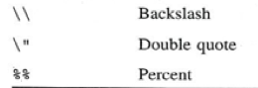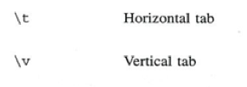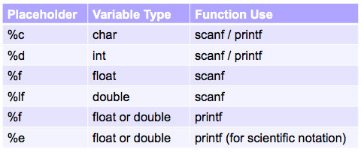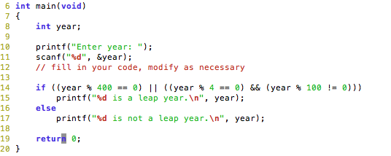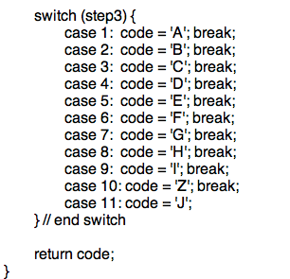Macintosh HD:Users:NeoHanWei:Desktop:Screen Shot 2012-02-17 at 3.11.34 PM.png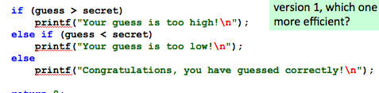

**- take note of format**

* **Extract DIGITS**
* **Invert number**

**- Expected input in certain format**

* **Returning a printf using a function call**
* **Void draw_circle(void);**
* **Elevator question**
* **Update the level step by step!**
* **Always use COUNT**
* **Printing all the digits in range [*0 - *9]**
* **while loop**

**- For loop**

- Printing SPECIFIC digit

**- INVERTING NUMBER**

**- Take note of FABS and ABS**

* **FINDING REVERSE NUMBERS**
* **E.G. 121 323 444 757**

**FIBONACCI SEQUENCE**

**- double digits**

**- for loop**

* **Print pattern**
* **Nested Loop**

**Switch**

**- Good while loop**

**- Nested Loop**

**- Sum of all the multiples of 3**

**Mock PE**

**- Reverse Number**

do{

printf(“%d”, I);

I += 2;

} while (I <= n);

**Common mistakes:**

* DO NOT PUT ; after while condition
* Positive:
* Remember to put == instead of =
* Format for do-while loop
* Format for for loop:

for (initialization; condition; update)

{

statement to execute

}

(condition: repeat loop while condition is true)

REMEMBER NO NEED TO PUT ; AFTER FOR

* Use **char** to capture special symbol (?) and letters (a, b ,d)

**Leap year**

**Returning a character**

**Return type char**

**Use of else if**